*Case Study 6.2:***Biking day with high carb lunch**  V.2.3

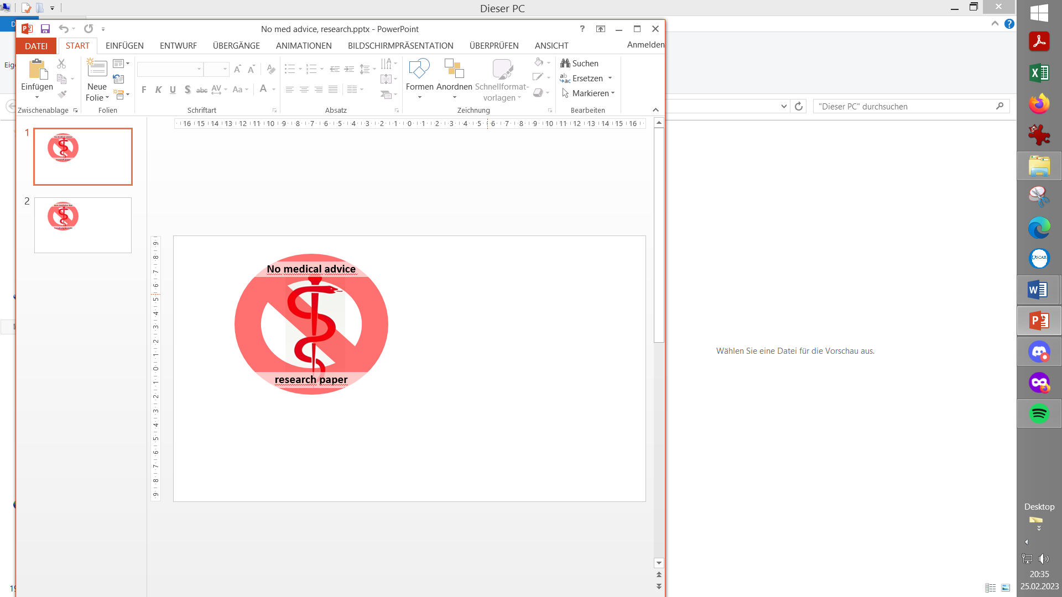

This case illustrates how an entire exercise day can be managed by the loop

nearly automatically, also in Full Closed Loop, when using the exercise mode

plus some Automations (as outlined in FCL e-book section 6.5.2).

Method

Intended exercise and targeted sensitivity modulation

The meal challenge

Automations installed for meal management with exercise following

Overall result

Preserving settings; DIY cockpit

Addendum: Logfile case analysis

Method

**Full Closed Loop** with dev variant of AAPS 3.2.0.2 w/autoISF 3.0.

Lyumjev 100 (DIA 7h) in Combo pump w/ 10mm Teflon cannula (0-48h)

2 x G6 overlapping; xDrip; no smoothing in AAPS

profile basal ~ 14 U (0.41…0.75 U/h); profile_ISF 36…44 mg/dl/U (circadian);

TDD 37 U

Main settings for 24/7 adaptation of ISF **\*)**:

SMB range extention and autoISFmax both = 2.9; SMB delivery ratio = 0.75 fixed

bgAccel_ISF_weight = 0.24; pp_ISF_weight = 0.03; dura_ISF_weight 0.8

**\*) Caution: Do not copy settings** from others,

not even for starting your tuning.

Why, see FCL e-book section 4.1.

iobTH_percent=60

Automations active: see under “Automations…”

**User interference**:

no boli ; no carb inputs ; no setting Eating Soon TT

Setting **% profile** and **TT** in top row of the AAPS main screen “to announce” exercise, before starting (just like done in Hybrid Closed Loop for exercise, too).

Because the case is complicated by also including a major meal in FCL, **one** additional (but time-uncritical) **manual step** is needed (that will start a “cascade of” Automations).

Occasionally *) having an eye on bg and on insulin activity curves = A few times, taking a small snack while biking

*) The curves, notably prediction curves, on the AAPS main screen (mounted on the bike handlebar) allow to judge at one glance, for how much longer there is sure safety to not need extra carbs against going low - and when, latest, to look again.

Intended exercise, and targeted sensitivity modulation

Leisure-time **biking** for about **4 hours** in total, with a sit-down longer lunch break.

I had only a minimal breakfast in order to keep **iob low when starting** to bike.

Rather I decided to carry along (in reach while biking) two protein bars (only 1 used, well before lunch, basically my breakfast replacement), and a couple of 2 grams glucose tablets.

*From past experience*, **70% profile** suits well, set already at least 2 hours ahead of starting to bike, and continuing (or slightly elevated to 80%) also in the night that follows.

Setting a 70% profile modulates my (average) 0.55 U profile basal to 0.7 * 0,55 = 0.39 U (see Addendum, emulator-line 20)

*In the past*, **glucose target** had been elevated to somewhere in the 120 to 170 range, out of a “gut feeling” looking at many factors, like current bg state, intensity of exercise, intended snacking.

*This time*, my setting had to consider the implications from the set TT on modulations that the (fairly new to me) exercise mode will do: In the **Exercise mode,** a **125 mg/dl TT** set translates …

… following a rather complicated calculation scheme, see autoISF Quick Guide p.7-9 at: <https://github.com/ga-zelle/autoISF>..

…into another (= getting multiplied) basal **reduction of 33 %**, to 67% of (70% of 0,55=)0,39U= 0,26 U overall resulted (see Addendum, emulator-line 19)

Taking %profile, Exercise mode, and TT setting together, the loop operates at a **modulated sensitivity** of only **47%** of its profile value (or of any autoISF adaptations based on it).

*Note that, also for* ***other types of exercise****, I can, over time, establish sets of suitable % profile reduction and of TTs, that would result in any desired different modulated % sensitivity.*

*Regarding preserving such settings for future use, see extra subchapter further below*

The meal challenge

Duck with French Fries and a salad bowl that included fruit.

No carbs were entered into AAPS, no bolus was given by the looper

Going into a high carb meal with only 47% “power” seems no good idea, regarding the to-be-expected bg spike, when not bolussing at all (= that precedes exercise must be managed in FCL mode with these cornerstones in mind:

1. Before lunch time, ending the exercise TT and going to (the much lower) profile bg target provides

* more iob
* opportunity that an Automation can become activated (at bg delta > 10 mg/dl) that temporarily further lowers the TT to 74 mg/dl, which **maximizes first SMBs for the intended high carb lunch**
* Overall, in this initial meal stage, the loop acts as aggressive “against” the high carb meal, as it would *outside of* an exercise context.

1. As exercise will (again) follow, it is here **very time critical** to end the 74 mg/dl TT again, so the exercise mode with its **125 mg/dl TT** can be immediately **re-installed**.

That is of high importance, because the exercise mode also results in a **dynamic_iobTH** which, like basal, also goes lower and ends the aggressive SMB fire against the high carb meal earlier. That facilitates continuing the exercise at an **elevated bg** level, and with **significantly reduced iob** (only ~47% of otherwise “allowed” level, in our case).

Note, starting exercise with low iob level was already our receipt for success in the morning.

*Rather than* tightly watching the AAPS screen during lunch, to **manually** enact this important switching from aggressive meal management towards pre-exercise slow-down, in exactly the right point of time (before iob shoots too high), *I had* **automated** *this* *procedure* with a cascade of 3 Automations:

Automations for fully automatic meal management with exercise following

I used a sequence of 3 Automations, of which only the first one had to be manually triggered, in just one time-uncritical key stroke from the AAPS home screen.

The others come on automatically when the respective Conditions are met.

Automation 1

The key first task was, to approach a meal that precedes exercise with full loop aggressive-ness, but to make sure that this aggressiveness stops immediately after a (reduced) iobTH is exceeded. The reduced iobTH ensures that not too much insulin is on bord for exercise after the meal. Also it provides an elevated bg level at (re-)start of exercise.

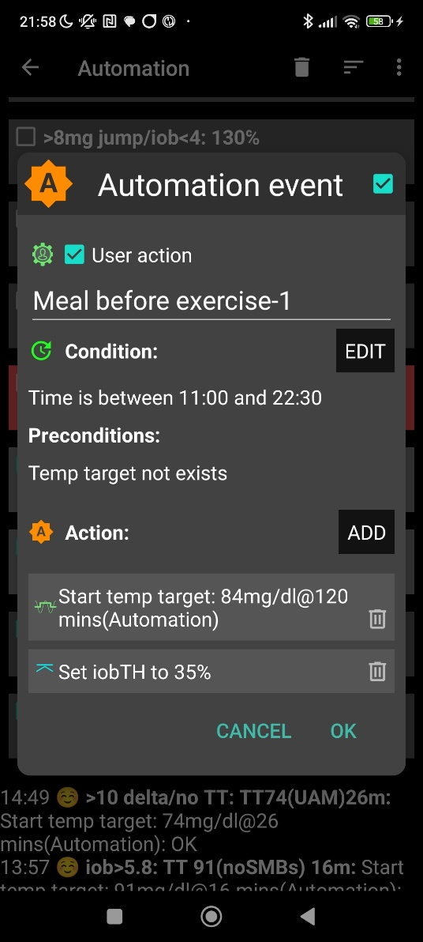

illustrative chart from another day

„User action“ is always ticked-on

This will, in the defined time space *) ..

..offer the “DIY cockpit” button..

..which I must press any time (~90…30 minutes) before my lunch.

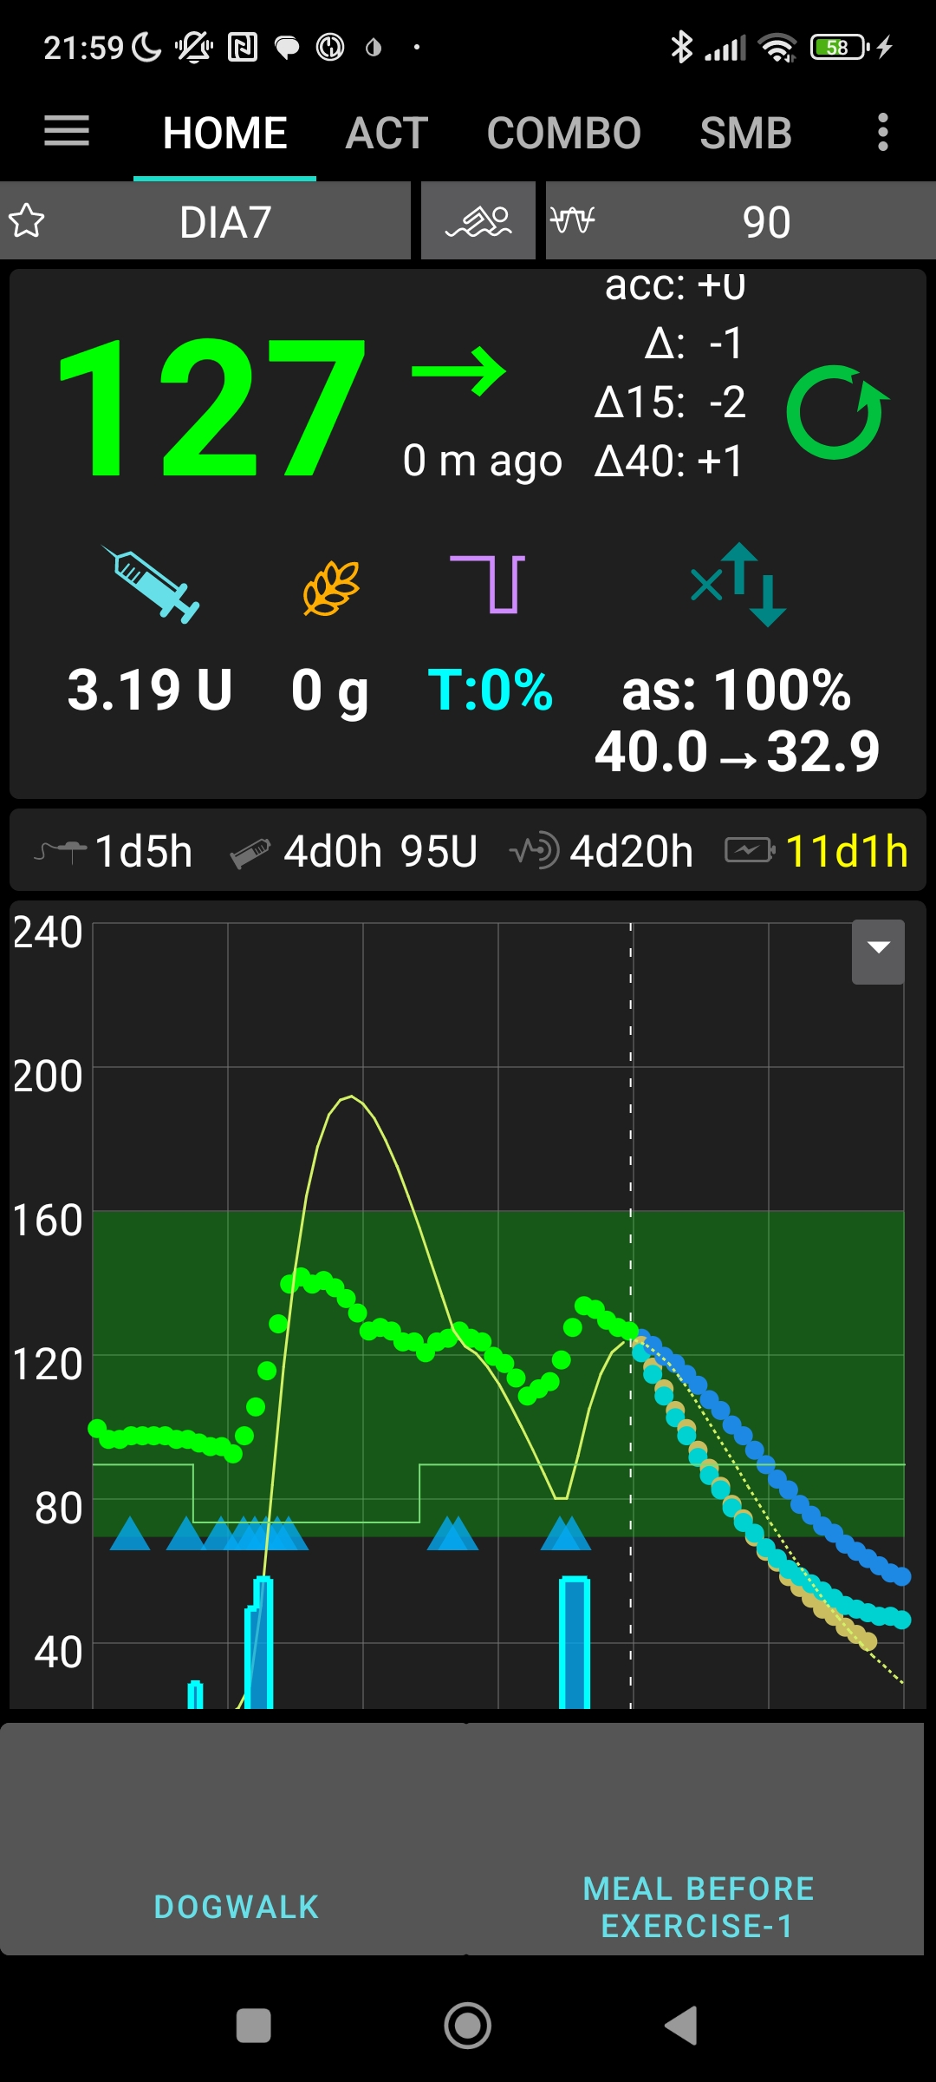

In this Automation, the box “User action” should be permanently ticked. This will automatically provide a grey button on the bottom of my AAPS home screen (“DIY cockpit”) that I can freely name (= headline of my Automation).

To keep the AAPS home screen as clean (and relevant) as can be, that button will show only in the time slot as specified under Conditions.

*) It will be reduced to something realistic. Only for development and testing purposes it had to extend into the night.

Automation 2

When (my in Automation 1, for exercise following the meal, to 35 % reduced iobTH that translates for me into) iob>3.8 is exceeded, I want two things:

1. The loop shall now automatically run milder, on my reduced exercise %profile (70%)(after the meal rise had been managed based on 100% profile, boosted by bgAccel_ISF driven full loop aggressiveness).
2. I like also to set a exercise TT. This, however, is not possible. I first have to force an end to my EatingSoonTT of 84:

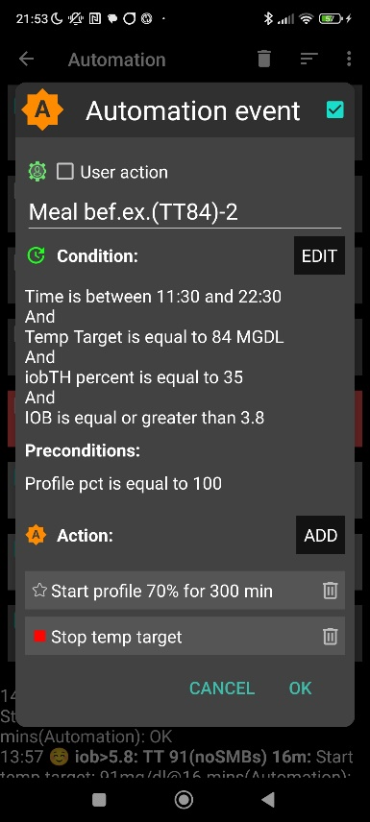

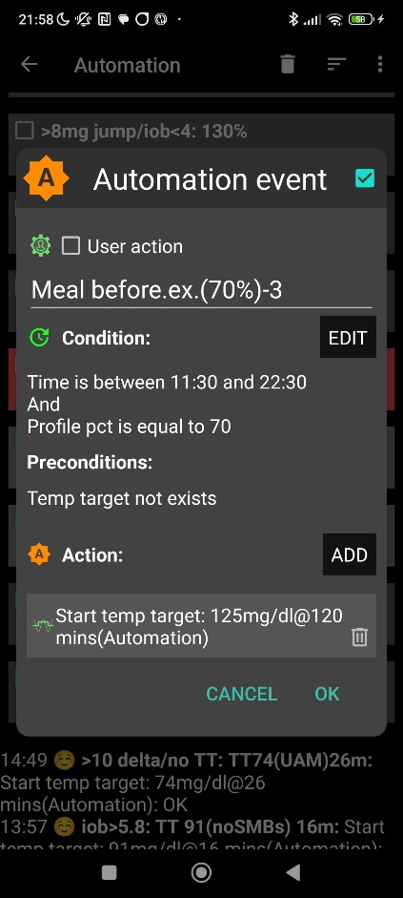

Automation 3

Now, that Automation 2 ended my TT of 84, Automation 3 can (max 5 minutes later) set the desired exercise TT=125 (which implies the exercise mode as in detail explained before).

Note that Automations 2 and 3 are fully automatic, no User Action involved.

Overall result

These measures lead to a pretty overall glucose curve for this biking day, which included a fairly substantial lunch (13:00 h, duck, french fries, a fancy salad with fruit in it), as well a piece of cake (16:00 h, at the end of the tour):

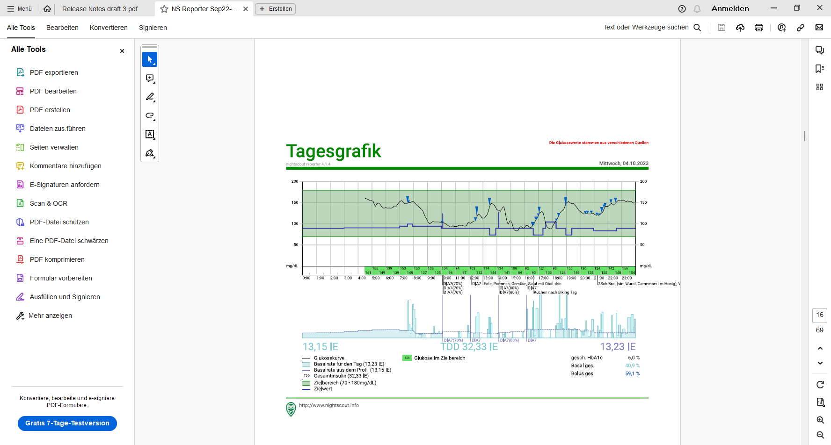

.

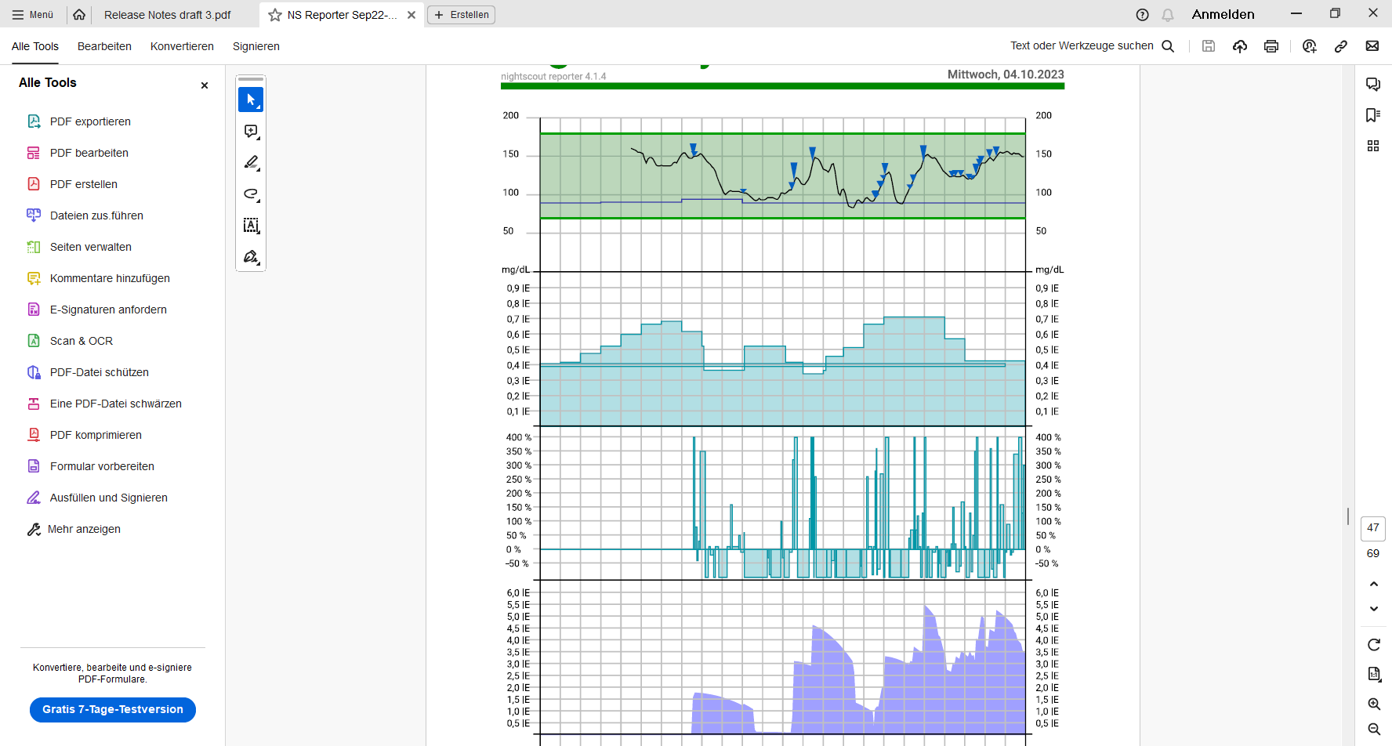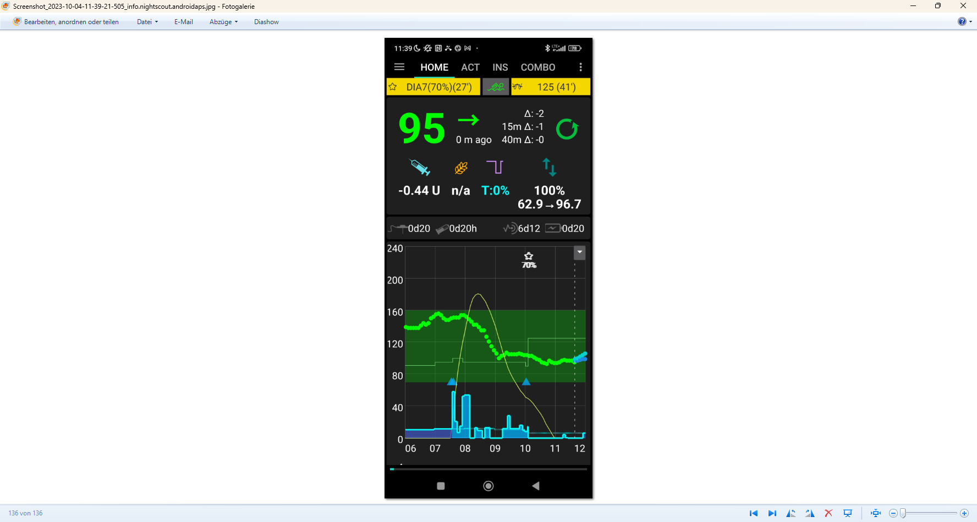

< **4.4 U**

The lunch iob hump in middle of the bottom graph (of the chart above, left) shows that the ~ 4 U iobTH was preventing higher iob as would be normal for a big lunch.

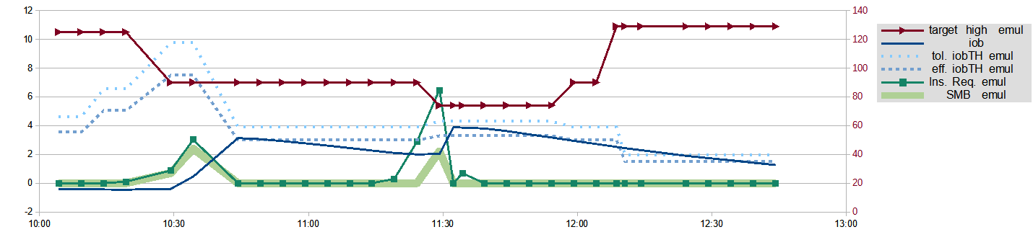

This chart from an emulator based analysis shows nicely how iobTH (dotted blue lines) changes with the TT set (red line, and scale with red numbers on the right):

Around 12:00 h TT 74 expired and profile target briefly was set, followed within a couple of minutes by switching back (as before 10:15 h in the morning biking time) to the 125 mg/dl exercise TT. This state allows only about 2 U as iobTH (see kink in the blue dotted line at 12:10 h), and my iob (blue curve) came nicely down to that low level, as desireable for sports - but sure unusual so shortly after eating a substantial meal.

Not astonishingly, few SMBs are in the picture (fat green line mostly at zero) and the loop can handle carbs in an exercise dominated period nearly by just elevating basal (%TBR up to 400%). (Actually, the very first graph shows for around 13:30 glucose from the meal had risen to about 140 mg/dl and one additional SMB was necessary, and was also possible because from around 12:45 the iob (blue line) was below the (dotted blue line: lowered) iobTH again, as this graph shows.

Summary

Using the **top button row** on the AAPS main screen, I just **input** the **70%** (for the whole day) and **125** mg/dl (for the first hours), which goes super fast and easy. It will immediately turn

* from all three fields grey,
* to „70%..“ on the profile field-turned-yellow, „125 .. „ in the TT field-turned-yellow, and also the exercise field lit yellow in the middle.

So, very easy to see on one glance, I am in the exercise mode, and which are the key settings (see picture with „95“ glucose).

Very roughly an hour before lunch time I activated the **User Action Automation** #1, reverting to profile target.

In just seconds I was able to „frame“ the upcoming exceptional situation for my loop, to manage me, from then on, fully automatically through the day!

And in case I would want to temporarily modify a parameter, or to prematurely exit: Same easy procedure, just within 1-2 seconds, right from my AAPS home screen.

The example demonstrated that using the exercise mode softened the loop response appropriately, while some Automations greatly helped to still get a major meal sufficiently treated under FCL conditions.

Preserving settings in **your** DIY cockpit

As I did in my initial set-up and tuning, you must first „learn“ from **your** past looping data (FCL and HCL), where about %profile and set TT should lie, for the kind of exercise that you occasionally were and are up to.

But, no need to make a science out of it. Unless you are competing in professional sports, it should be good enough to go by gut feeling, and by experience („what setting should I slightly alter the next time?“).

As the loop re-calculates every 5 minutes, it is *not* important to get things *exactly* right. Automatic adjustments (every 5 minutes) allow the loop to still keep things under good-enough control.

The time windows for doing the profile switch, and for setting a suitable TT can differ (and they can also be automated, so not to require multiple inputs over the course of your exercise day).

**Using all available tools allows a nearly surgical approach to what you want to achieve for your favourite type(s) of exercise**.

Observe that your general setting (in AAPS Preferences) for **half-basal exercise target** strongly influences where you land in your attempts to assign feasible TTs for various exercise types. (More see autoISF Quick Guide p.7-9 at: <https://github.com/ga-zelle/autoISF> or FCL e-book section 6.1.3).

Define one **User Action Automation** for each type of exercise, and name it as you would like to see the according button labelled on your AAPS main screen.

If needed, define automatically triggered adjunct/tandem Automations (like we needed in our very special case with a major meal inside the exercise activities)

To limit the number of buttons in your “cockpit”:

* Assign time spans in the Conditions (when, in any 24 h period, can this exercise happen?)
* Completely dis-activate (“shelve”) those Automations, that are for types of exercise that do not frequently occur

**Caution**: As mentioned in other places, Automations can be tricky as to whether they actually will ever work, because the loop goes through the exact **sequence of all your active Automations**, and might be switched into a direction that no longer is compatible with the conditions that must be a given, for the Automation you think that should kick in.

Addendum: Logfile analysis with the emulator

Skip this last section, unless you like to learn more about using the emulator.

Analysis of my biking day with the emulator required to load the logfiles from my phone into the PC, and to have the files for the emulator downloaded from Github.

1. Load an empty vdf file, and access to logfiles (erasing the end with UTZ time, and putting an asterics after date_ => all of that date get loaded into the mask
2. Define the time window of interest, using UTZ (= MEZ summertime minus 2) in the last two lines (right hand side input fields) of the form:

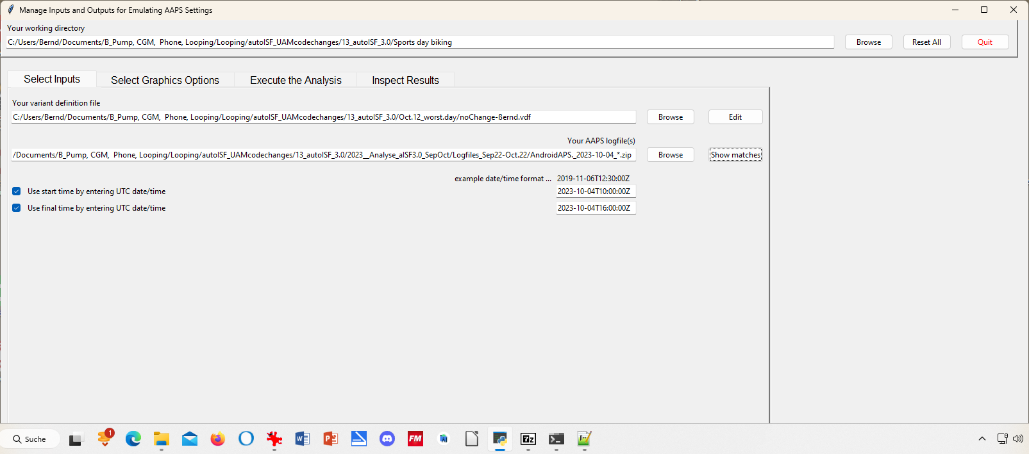

1. Execute Analysis / Run Emulation yields results as table:

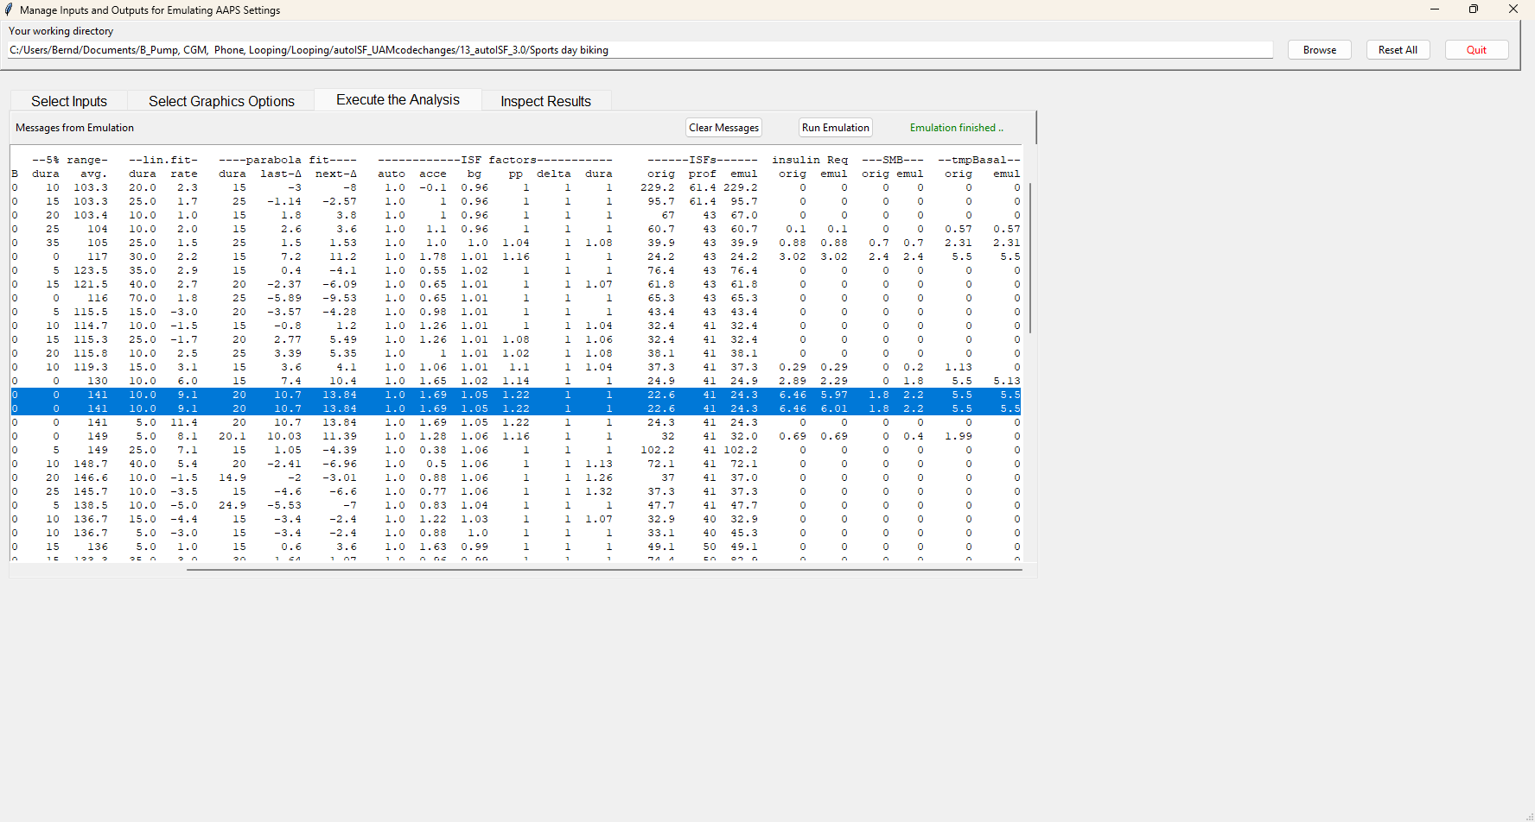

In line 6 (12:34 CET) a 2.4 U big SMB is given, driven by bgAcel_ISF factor of 1.78

Highlighted is 13:29 CET (for some reason there is duplicated line for it). Here, a big insulinReq of 6,5 U is cut down to a SMB of only 1.8 U..

1. … to see how our settings, TT and and sports button worked here, and what iobTH applied, we must look into the logs available from: ((alternatively, the SMB tab from exactly those 5 minutes would show, too))

Instead of Execute Analysis, press Inspect results…



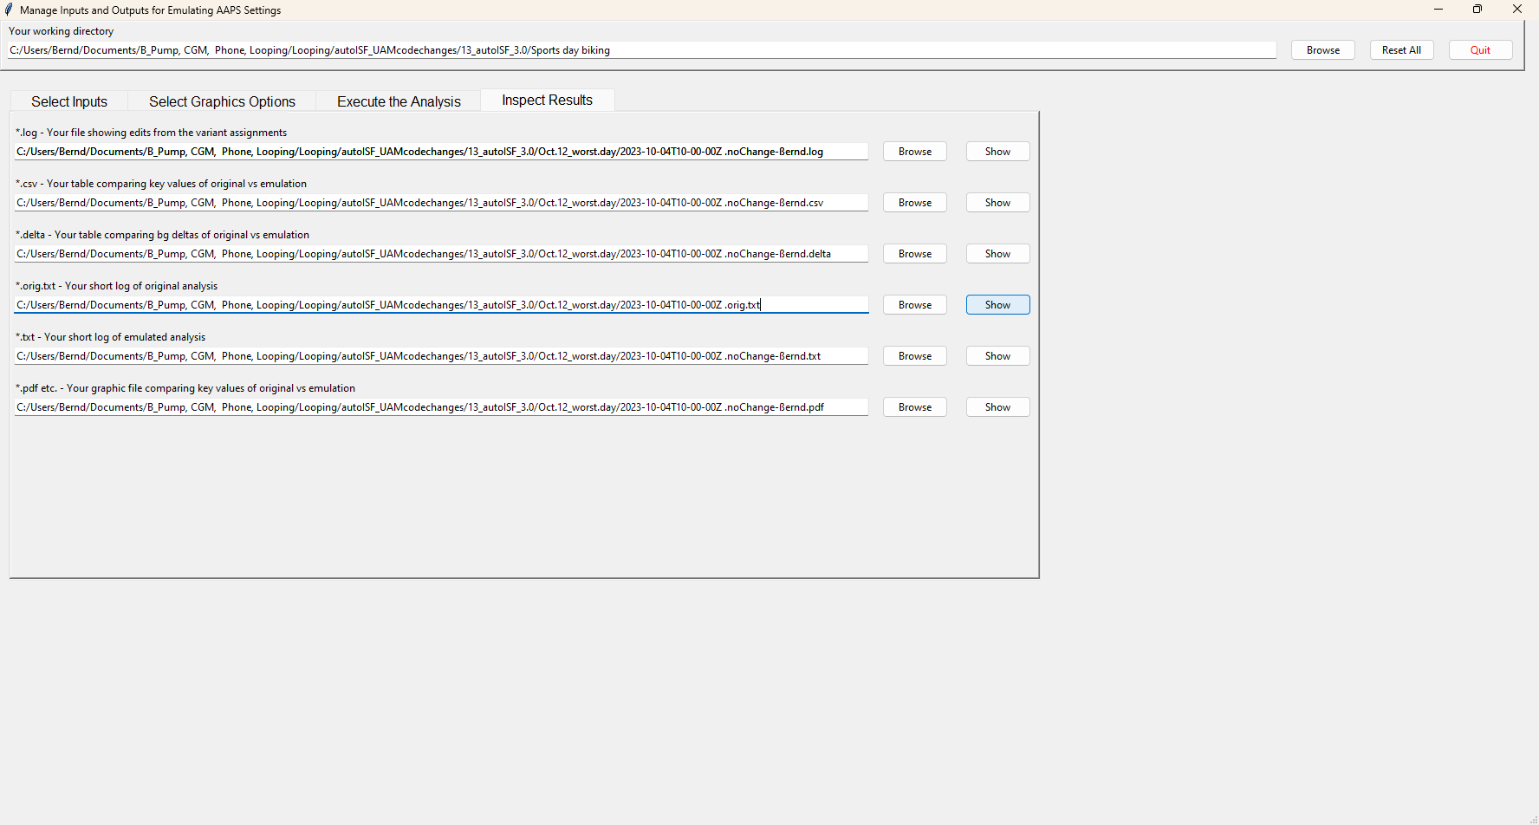

If you press the 4th option you get the logs which include basically all SMB tab info in an exhaustively long list.

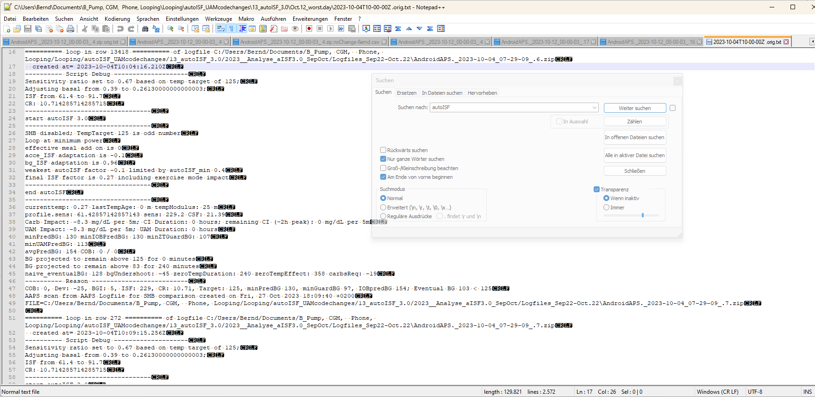

The blue highlighted line shows we are at 10:04 UTZ (12:04 CET) . We can see how sensitivity ratio and also basal were lowered due to sports setting with a 125 mg/dl TT, or 129 used a bit later, which also disabled SMBs.

By using the search function you can jump, in that long list, to all places that e.g. have „autoISF“ in it, or „script debug“, or „SMB disabled“ (if you want to analyze when that happened…)

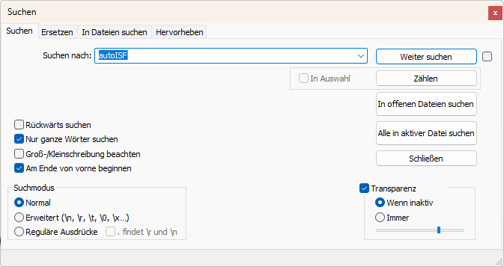

1. Now lets look at 11:29 UTZ (13:29 CET) which was when the first relevant size SMB was issued:

In the following, I copy and shorten texts from the log table as above, for some time points of high interest:

11:29 UTZ (13:29 CET), when SMB was delivered:

loop in row 14007 …..created at= 2023-10-04T11:29:11.005Z

---------- Script Debug --------------------

Sensitivity ratio set to 1.1 based on temp target of 74;

Adjusting basal from 0.55 to 0.6050000000000001;

ISF from 41 to 37.3

CR: 7.5

So, we see the meal TT of 74 (set by one of my Automations for cases in which I did not bother to set an EatingSoonTT) temp. overrides the exercise target and sharpens the applicable ISF: ((It also elevates basal ; note that TBRs can run several 100% of basal))

----------------------------------

start autoISF 3.0

----------------------------------

SMB enabled; TempTarget 74 is even number

Loop at full power

acce_ISF adaptation is 1.81

bg_ISF adaptation is 1.05

pp_ISF adaptation is 1.22

dura_ISF by-passed; bg is only 0m at level 141

final ISF factor is 1.81

----------------------------------

end autoISF

----------------------------------

profile.sens: 41 sens: 22.6 CSF: 3.01

minPredBG: 220 minIOBPredBG: 135 minZTGuardBG: 94 minUAMPredBG: 231

avgPredBG: 220 COB: 0 / 0

BG projected to remain above 74 for 240 minutes

IOB 2.033

Full loop capped SMB at 1.87 to not exceed 130 % of effective iobTH

Here we see that our, for the exercise day significantly lowered, iobTH not only blocked SMBs above that lower threshold. Also the 30% “the last” SMB is max. allowed to go beyond the valid iobTH now amounts to significantly less.

So, while, as intended for start of a high carb meal, my loop is at full power (line 209), the last SMB (line 223) got capped to way below insulinReq (line 231).

… maxBolus: 3.2

---------- Reason --------------------------

Eventual BG 304 >= 74, insulinReq 6.46. Microbolusing 1.8U. adj. req. rate: 13.53 to maxSafeBasal: 5.5, temp 2.75 < 5.5U/hr.

1. A look at the cake after 14:20 (16:20 CET):™

From 14:09 UTZ (16:09 CET) on, I discontinued the sports TT and the loop reverted to 90 mg/dl profile target.

As desired for starting to eat cake, this made SMBs possible, and the only reduction of FCL aggressiveness was the 70% due to temp. profile set for this sports day.

However, 14:14 - .19 - .24 and :29 there was no insulinRequired yet (while ISF factor gradually ramped up from 0.52 to 1,09 (line 1735, 1772, 1807) .

At 14:34 UTZ (16:34 CET) a first cake related SMB of 0.5 U was issued based on 0,66 U ins.Requ (line 1897), and based on a bgAccel_ISF factor of 1,54 (and final ISF factor of 1,52).

As there is a **>10 mg/d delta** (glucose rise), **my Automation** kicks in and sets for the next loop decisions (for 26 minutes is as my Automation defines it) a **TT=74** mg/dl which makes the loop more aggressive from 14:37 on:

created at= 2023-10-04T14:37:15.371Z

---------- Script Debug --------------------

Sensitivity ratio set to 1.1 based on temp target of 74;

Adjusting basal from 0.48 to 0.528;

ISF from 39 to 35.5

CR: 6.6

----------------------------------

start autoISF 3.0

----------------------------------

SMB enabled; TempTarget 74 is even number

Loop at full power

acce_ISF adaptation is 1.64

bg_ISF adaptation is 1

pp_ISF adaptation is 1.08

dura_ISF adaptation is 1.11 because ISF 35.5 did not do it for 30 m

final ISF factor is 1.64

----------------------------------

end autoISF

----------------------------------

profile.sens: 39 sens: 23.8

avgPredBG: 94 , BG projected to remain above 74 for 240 minutes

IOB 0.438 Eventual BG 100 >= 74, insulinReq 0.84. Microbolusing 0.6U.

created at= 2023-10-04T14:39:16.537Z

---------- Script Debug --------------------

Sensitivity ratio set to 1.1 based on temp target of 74;

Adjusting basal from 0.48 to 0.528;

ISF from 39 to 35.5

CR: 6.6

----------------------------------

start autoISF 3.0

----------------------------------

SMB enabled; TempTarget 74 is even number

Loop at full power

effective meal add on is 0.04

acce_ISF adaptation is 1.25

bg_ISF adaptation is 1

pp_ISF adaptation is 1.06

dura_ISF by-passed; bg is only 5m at level 97.5

final ISF factor is 1.25

----------------------------------

end autoISF

----------------------------------

profile.sens: 39 sens: 31.2

avgPredBG: 78 BG projected to remain above 74 for 240 minutes

IOB 1.114

Eventual BG 84 >= 74, insulinReq 0.13; setting 30m low temp of 0.04U/h. Microbolusing 0.1U.